## Higher National Diploma in Information Technology

**Object Oriented Programming**

**Lab Sheet 06**

28. Write a program that prompts the user to enter two floating point (double) numbers and an operator ( *, +, /, %, -). Print the results of the given operation. For reading the command line, use the Scanner class. Write the program first using switch logic, then re-write the program using if/else logic.

29. Write a Java program to do the following that determines your weight on another planet. The program should ask for the user's weight on Earth, then present a menu of the other planets in our solar system. The user should choose one of the planets from the menu. The program should display the phrase like the following: “Your weight on Mars is 55 lbs.” Use the following conversion factors:

**Planet Conversion factor**

**(multiply your Earth weight by this number**

**to determine your weight on this planet)**

Mercury 0.38

Venus 0.91

Mars. 0.38

Jupiter 2.36

Saturn 0.92

Uranus 0.89

Neptune 1.13

30. A professor in college will allow a student to be excused from the final exam if either of the following is true:

• They have a 90% average or higher in the class and have missed 3 or less class lectures.

• They have a 80% average or higher in the class and have not missed any class

lectures.

The program below will determine whether a student can get out of the exam or not.

Rewrite the program so only one if statement is used.

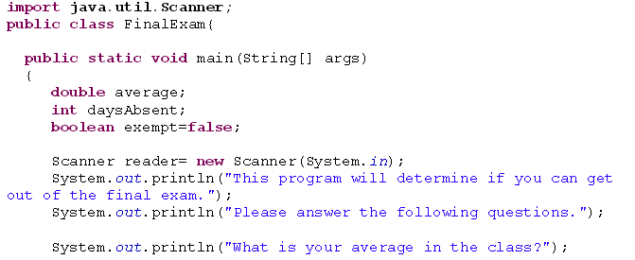

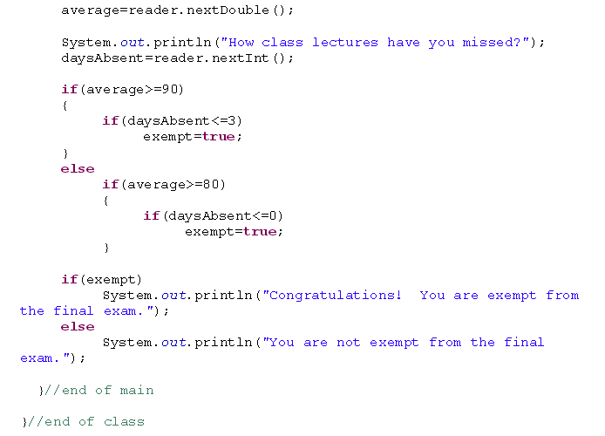

31. Write a program that calculates the number of buckets of paint to use for a room and the optimal number of cans to purchase. You need to ask the height of the room and the length and width of the room. The room is rectangular. You must paint the walls and the ceiling but not the floor. There are no windows or skylights. You can purchase the following size buckets of paint.

5-liter bucket costs $15 each and covers 1500 square feet.

1-liter bucket costs $4 and covers 300 square feet.

32. Consider you are asked to decode a secret message. The coded message is in

numbers and each number stands for a specific letter. You discover enough of the

secret code to decode the current message.

So far, you know:

1 represents “D”

2 represents “W”

3 represents “E”

4 represents “L”

5 represents “H”

6 represents “O”

7 represents “R”

Write a program that prompts the user for 10 numbers, one at a time, and prints out the

decoded message. If the user enters a number that is not one of those already deciphered, prompt him/her for a new number. Test your code with the following input:

5 3 4 4 6 2 6 7 4 1